**Attenuator Design**

**Criteria:** We need a step attenuator capable of going from 5mV, zero to peak, to 1uV RMS or maybe 0.5uV RMS, to test our radio receivers using the Analog Discovery 2 boards from Digilent. You should download and install the Waveforms program. You can run it before you receive your Analog Discovery 2 board and see that the lowest output from the board is 5mV, zero to peak. It is important that you realize the stray capacitance and mutual inductance can bypass your attenuator if you don’t design it correctly. We need these attenuators to work to at least 30MHz. I suggest using at least five stages, and 0.1” headers and jumpers for the switches needed. Model your design in LTSpice for the highest attenuation at 30 MHz to make sure it will work. If you have trouble, contact me, and I can help. I have only done a very quick approximation to be fairly certain this should be possible. Then design the PCB in KiCad. As you do, try to make the traces have a characteristic impedance, Z0 of fifty ohms. There is a calculator in KiCad that will help you with that problem. You can choose if you want surface mount or through hole components. We are sending you soldering irons, but they probably are not as good as the school’s irons, so soldering surface mount components may be more difficult for you.

**Design:** I started by determining the amount of attenuation we needed in terms of decibels. This was done using the equation:

where in our case, and . Thus, our decibel attenuation was determined to be:

We can now design our attenuator so that we have a total decibel drop close to 80. However, to compensate for the capacitance in the circuit (capacitance values calculate in appendix A), and to adjust to have a value of around at a frequency of while having minimal distortion at , we chose a loss of 74 dB. The stray capacitance was factored into the simulation, but mutual inductance was neglected, as we presumed that it would be negligible since we planned on constructing the attenuator in a linear fashion. We decided to have 5 stages, each with a loss of 14.8 dB for simplicity and to minimize the amount of distortion the circuit sees at higher frequencies. To calculate the resistor values, we performed the following calculations, whose results are summarized in table 1.

We then looked a common resistor value table and took the closest actual resistor values to place in our simulation in LTSpice.

|  |  |  |  |
| --- | --- | --- | --- |
| dB Loss | K Factor | 50 Impedence | |
| **R1, R3** | **R2** |
| 14.8 | 5.49541 | 73.2 | 133 |

Table . Calculated resistor values based on a 15 dB attenuation per stage of the attenuator circuit.

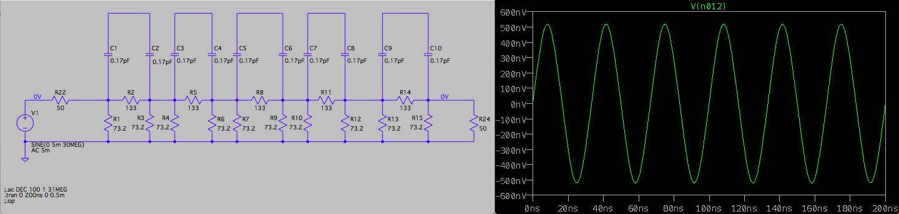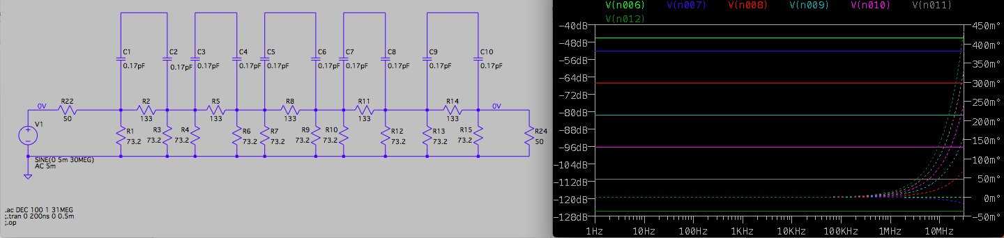**Simulation:** The LTSpice simulation was modeled as shown in Figure 1 and Figure 2. From these simulations, we see that even with the stray capacitance factored into the simulation, the circuit functions as expected. An input signal of 5mV is attenuated to somewhere between 0.35uV to 1uV depending on the frequency of the signal.

Figure 2. The attenuator circuit simulation in LTSpice with transient analysis shown on the right at a frequency of 20MHz and input signal of amplitude 5mV. We see that the output voltage is just at 0.5uV therefore meeting the design criteria.

Figure .The attenuator circuit simulation in LTSpice with ac analysis shown on the right, with probes at each stage in the attenuator. The magnitude across the load resistor starts at -128dB, increasing to -126.8dB by 32MHz.

**PCB Design:** We used KiCad to design our PCB. We are using jumpers between pins as our pseudo switches, therefore 1x3 connectors were used to model each switch. We decided on using through hole resistors (THT-resistors) for ease of soldering them onto the completed board. For power supply to the board, we used coaxial connectors. The parts list is provided in the figure below, along with documentation of the KiCad Schematic and PCB Design. We ordered the boards to be printed from JLC PCB.

Resistor_THT:R_Axial_DIN0207_L6.3mm_D2.5mm_P7.62mm_Horizontal

PCB calculator:

TRANSLINE

Microstrip Line

Ordered from JLC PCB

**Appendix A:** Created by Dr. Frohne

